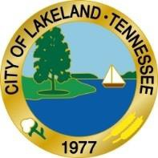

Date of Event: **Saturday, October 22, 2022, 10 a.m. to 2 p.m.**

Name of Event: **Harvest Festival 2022**

Location: **Athletic Complex, 9661 Memphis-Arlington Rd**

Vendors are responsible for leaving the area in the same condition as they found it.

**Cost:** No fee to vendors giving out free products, coupons, promotional items, etc., and $50.00 for those selling products.

Vendors must provide their own equipment ie: canopies, chairs etc.

All fees are non-refundable as they are used to promote the events.

No electricity or running water is available.

Our event will run from 10:00 pm to 2:00 pm

Be there early enough to setup

Set up Time: Vendors can begin set up as earlier as 5:30 pm

**City of Lakeland Vendor Application**

We reserve the right to censor any booth.

**REGISTRATION**: Vendor Forms must be submitted one week before the event!

COMPANY:

CONTACT PERSON:

ADDRESS:

PHONE:_

EMAIL:

Description of items to sell (If Selling):

Total Amount submitted:

City of Lakeland, their workers, volunteers and facility will not be held responsible for any

liability, lost or stolen or damaged merchandise or any injury incurred during the event.

Signature of Vendor Date

Make Checks payable to: City of Lakeland, 10001 US Highway 70, Lakeland, TN 38002

10001 US Highway 70, Lakeland, TN 38002

Phone 901-867-2717 Fax 901-867-2063